

**A**

**REPORT**

**On**

**WEB DATABASE PROGRAMMING LAB**

**Course Code: *CSE-408***

**Submitted To:**

**MD. ATAULLAH BHUIYAN***Lecturer Department of CSE  
City University*

**Submitted By:**

***Md Rasel Hossain- 163432521***

***Submission Date: 5-08-2020***

**ABSTRACT**

My project is **Bookz Kart**. This is a website which helps students to find and buy all type of books on internet. It is useful in the way that it makes an easier way to buy and sell books online. **Bookz kart** is an interactive e-commerce solution providing users with an opportunity to buy and sell books. Bookz Kart is the first online platform which deals with new and old books of all fields.

In this website we have basically 2 modules. The first module includes the customer module and second module includes admin module.

The customer have to register for any enquiry related to books. The registered customer can view details of books and he/she can buy or sell the books of his/her need. He/she has to pay and will get home delivery.

The admin module contains the access of admin page on the website. The admin can change everything in the website. He have the ability to add, delete, and update any information regarding the books.

**List of Content Title**

**List of Content Page**

1. Abstract------------------------------------------------------------------2
2. Introduction-------------------------------------------------------------3
3. Objectives---------------------------------------------------------------3
4. Web Development-----------------------------------------------------3
5. The Steps to Create a Web site UI development-----------------4-6
6. Hardware Requirement------------------------------------------------7
7. Software Requirement-------------------------------------------------7
8. Data Flow Diagram----------------------------------------------------8
9. Future scope and future enhancement-------------------------------13
10. Conclusion--------------------------------------------------------------13
11. Reference---------------------------------------------------------------13

**INTRODUCTION:**

An integral part of our Bangladesh Society and it is important for every individual to succeed in his life and help bring change to our world. In a country with more than people living, for everyone individual education is essential. To keep learning and developing themselves and helping our environment, economy, social life be sustainable.

**Bookz kart** is an interactive e-commerce solution providing users with an opportunity to buy and sell books. Bookz Kart is the online platform which deals with new and old books of all fields, we deliver a constructive service to each and every person needs in terms of learning, education and technology by providing them with an online platform where they can Buy and sell books for affordable price and even they can sell their used books on our website and also get books on rent. Bookz kart provides users with wide range of pre-owned books which get a check based on their condition and fixed to its best and delivered to consumer’s doorsteps.

**OBJECTIVES:**

Online Shopping is the process whereby consumers directly buy goods and services without any intermediary service over the internet. The goal of this website is to develop a web based interface for students of Jammu and Kashmir, the website would be easy to use and hence the shopping experience pleasant for the users. The main goal of this website is:

I. To develop an easy to use web based interface where students can search for products (books), view a complete description of the product and order the product.

II. A student can buy and sell books from home.

III. A student can get books on rent.

**WEB-DEVELOPMENT:**

**Web development is** a broad term for the work involved in developing a web site for the Internet (World Wide Web) or an intranet (a private network). Web development can range from developing the simplest static single page of plain text to the most complex web-based internet applications, electronic businesses, and social network services. A more comprehensive list of tasks to which web development commonly refers, may include web engineering, web design, web content development, client liaison, client-side/side scripting, web server and network security configuration, and e-commerce development. Among web professionals, "web development" usually refers to the main non-design aspects of building web sites: writing markup and coding. Most recently Web development has come to mean the creation of content management systems or CMS. These CMS can be made from scratch, proprietary or open source. In broad terms the CMS acts as middleware between the database and the user through the browser. A principle benefit of a CMS is that it allows non-technical people to make changes to their web site without having technical knowledge.

For larger organizations and businesses, web development teams can consist of hundreds of people (web developers) and follow standard methods like Agile methodologies while developing websites. Smaller organizations may only require a single permanent or contracting developer, or secondary assignment to related job positions such as a graphic designer or information systems technician. Web development may be a collaborative effort between departments rather than the domain of a designated department. There are three kind of web developer specialization: front-end developer, back-end developer, and full-stack developer.

**THE STEPS TO CREATE A WEB SITE:**

Creating a web site requires multiple steps which includes the following:

• Creating a UI(User interface)

• Scripting(Both at server end and client end)

• Creating a backend or the database

**UI DEVELOPMENT**

Technologies that are mostly used to develop a User Interface are:

• HTML

• CSS

• Bootstrap.

HTML

**Hypertext Markup Language** (**HTML**) is the standard markup language for creating web pages and web applications. With Cascading Style Sheets (CSS) and JavaScript it forms a triad of cornerstone technologies for the World Wide Web. Web browsers receive HTML documents from a web server or from local storage and render them into multimedia web pages. HTML describes the structure of a web page semantically and originally included cues for the appearance of the document

CSS

**Cascading Style Sheets** (**CSS**) is a style sheet language used for describing the presentation of a document written in a markup language. Although most often used to set the visual style of web pages and user interfaces written in HTML and XHTML, the language can be applied to any XML document, including plain XML, SVG and XUL, and is applicable to rendering in speech, or on other media. Along with HTML and JavaScript, CSS is a cornerstone technology used by most websites to create visually engaging WebPages, user interfaces for web applications, and user interfaces for many mobile applications.

**BOOTSTRAP**

**Bootstrap** is a free and open-source front-end web framework for designing websites and web applications. It contains HTML- and CSS-based design templates for typography, forms, buttons, navigation and other interface components, as well as optional JavaScript extensions. Unlike many web frameworks, it concerns itself with front-end development only.

Bootstrap is the second most-starred project on GitHub, with more than 107,000 stars and 48,000 forks.

**SCRIPTING**

There are two scripting methodologies.

1. Server side scripting: This scripting is done at the server end

2. Client side scripting: This scripting is done at the client end or the browser.

**SERVER SIDE SCRIPTING**

**Server-side scripting** is a technique used in web development which involves employing scripts on a web server which produce a response customized for each user’s (client’s) request to the website. The alternative is for the web server itself to deliver a static web page. Scripts can be written in any of a number of server-side scripting languages that are available (see below). Server-side scripting is distinguished from client-side scripting where embedded scripts, such as JavaScript, are run client-side in a web browser, but both techniques are often used together.

**Server Side scripting Languages**

There are several languages that can be used for server-side programming:

• PHP

• ASP.NET (C# OR Visual Basic)

• C++

• Java and JSP

• Python

• Ruby on Rails and so on.

**CLIENT SIDE SCRIPTING:**

Client-side scripting is changing interface behaviors within a specific web page in response to mouse or keyboard actions, or at specified timing events. In this case, the dynamic behavior occurs within the presentation. The client-side content is generated on the user's local computer system.

Such web pages use presentation technology called rich interfaced pages. Client-side scripting languages like JavaScript or Action Script, used for Dynamic HTML (DHTML) and Flash technologies respectively, are frequently used to orchestrate media types (sound, animations, changing text, etc.) of the presentation. Client-side scripting also allows the use of 20

**DATABASE**

A database is an organized collection of data. It is the collection of schemas, tables, queries, reports, views, and other objects. The data are typically organized to model aspects of reality in a way that supports processes requiring information, such as modelling the availability of rooms in hotels in a way that supports finding a hotel with vacancies.

A **database management system** (**DBMS**) is a computer software application that interacts with the user, other applications, and the database itself to capture and analyze data. A general-purpose DBMS is designed to allow the definition, creation, querying, update, and administration of databases. Well-known DBMSs include MySQL, PostgreSQL, MongoDB, MariaDB, Microsoft SQL Server, Oracle, Sybase, SAP HANA, MemSQL and IBM DB2

**SQL**

Originally based upon relational algebra and tuple relational calculus, SQL consists of a data definition language, data manipulation language, and data control language. The scope of SQL includes data insert, query, update and delete, schema creation and modification, and data access control. Although SQL is often described as, and to a great extent is, a declarative language (4GL), it also includes procedural elements.

**Hardware Requirements:**

The selection of hardware is very important in the existence and proper working of any software. When selecting hardware, the size and requirements are also important.

|  |  |
| --- | --- |
| Processor | Intel CORE i5 |
| RAM | **4.0 GB** |
| Hard Disk Drive | **500 GB** |

**Software Requirements:**

|  |  |
| --- | --- |
| **Number** | **Description** |
| 1 | Windows 7,8,10 |
| 2 | HTML/Css /JavaScript/  Bootstrap. |
| 3 | Apache server/ XAMP SERVER |
| 4 | PHP |
| 4 | MySQL |
| 5 | Compiler: MSVC11 (Visual C++) |
| 6 | Apache version: Apache/2.4.23 (Win32) |

**DATA FLOW DIAGRAM:**

Data Flow Diagrams show the flow of data from external entities into the system, and from one process to another within the system. There are four symbols for drawing a DFD:

I. Rectangles representing external entities, which are sources or destinations of data.

II. Ellipses representing processes, which take data as input, validate and process it and output it.

III. Arrows representing the data flows, which can either, be electronic data or physical items.

IV. Open-ended rectangles or a Disk symbol representing data stores, including electronic stores such as databases or XML files and physical stores such as filing cabinets or stacks of paper.

Figures below are the Data Flow Diagrams for the current system. Each process within the system is first shown as a Context Level DFD and later as a Detailed DFD. The Context Level DFD provides a conceptual view of the process and its surrounding input, output and data stores. The Detailed DFD provides a more detailed and comprehensive view of the interaction among the sub-processes within the system.

Fig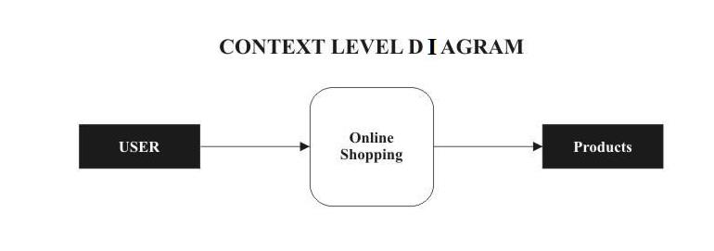

DFD-1

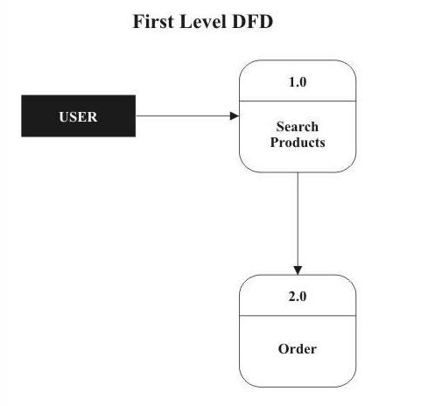

DFD-2

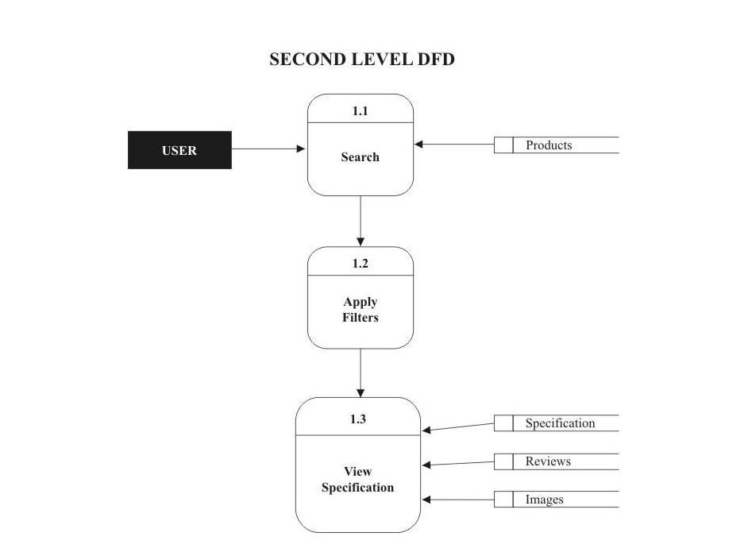

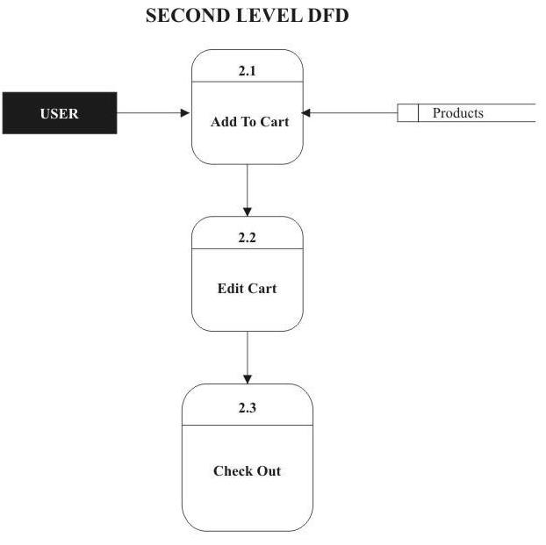

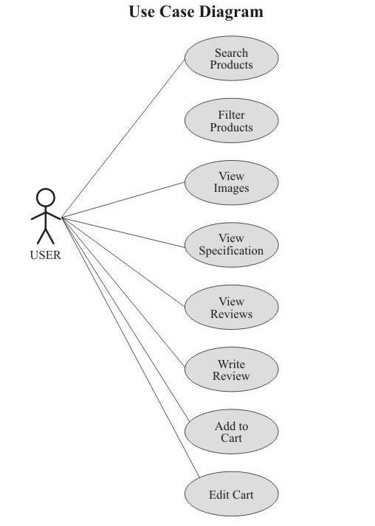

**FUTURE SCOPE & FUTURE ENHANCEMENT**

**PROJECT NAME:** Bookz Kart

1. Bookz Kart would help each and every person to find any book via our website and get it at home it will save their time.

2. It would provide huge collection of books of all fields.

3. Students will also get audio/video series of courses, i.e. they can learn online/offline.

4. We will be providing some special courses both online and offline.

**CONCLUSION:**

We have successfully implemented the site ‘Bookz Kart’. With the help of various links and tools, we have been able to provide a site which will be live soon and running on the web. We have been successful in our attempt to take care of the needs of both the user as well as the administrator. Finally we hope that this will go a long way in popularizing.

**REFERENCE**

1. www.javatutpoint.com

2. www.w3schools.com

3. www.getbootstrap.com

4. www.codeigniter.com

5. www.stackoverflow.com

6. www.fontawesome.io

7. www.php.net

8. Learn HTML and CSS

9. Wikipedia